**Natural Gas Price Forecasting using Statistical Models and Deep Learning Models**

*Note: Sub-titles are not captured in Xplore and should not be used

line 1: 1st Given Name Surname   
line 2: *dept. name of organization   
(of Affiliation)*  
line 3: *name of organization   
(of Affiliation)*line 4: City, Country  
line 5: email address or ORCID

line 1: 4th Given Name Surname  
line 2: *dept. name of organization*  
*(of Affiliation)*  
line 3: *name of organization   
(of Affiliation)*line 4: City, Country  
line 5: email address or ORCIDline 1: 2nd Given Name Surname  
line 2: *dept. name of organization   
(of Affiliation)*  
line 3: *name of organization   
(of Affiliation)*line 4: City, Country  
line 5: email address or ORCID

line 1: 5th Given Name Surname  
line 2: *dept. name of organization   
(of Affiliation)*  
line 3: *name of organization   
(of Affiliation)*line 4: City, Country  
line 5: email address or ORCIDline 1: 3rd Given Name Surname  
line 2: *dept. name of organization   
(of Affiliation)*  
line 3: *name of organization   
(of Affiliation)*line 4: City, Country  
line 5: email address or ORCID

line 1: 6th Given Name Surname  
line 2: *dept. name of organization   
(of Affiliation)*  
line 3: *name of organization   
(of Affiliation)*line 4: City, Country  
line 5: email address or ORCID

***Abstract*— Natural gas, entitled as methane gas or natural methane gas, is a highly flammable, colorless, odorless gaseous hydrocarbon where ethane and methane forms the core. A petroleum resource which is associated with crude oil, burning it results in less emission of carbon which promotes a sustainable environment. In order to be extremely safe, go ecogreen, reduce dependency on nations for fuel resources it is even more tactical to forecast the prices of natural gasses in the international market for a time frame. The present models shine either on statistical or deep learning models making it a. Thus, an ARIMA model is developed initially by using the updated dataset(nasdaq) for the forecast to predict the closing price of the day. The autoregression predicts the upcoming values(closing price) based on then values. Moving Averages play a crucial role in smoothing the time series data. Secondly, the LSTM model is constructed with the same dataframe. LSTM uses recurrent neural networks (RNN). The ideology behind the model is that at times being conscious of recent information to perform the present task. Bidirectional LSTM is also constructed. The Neural Prophet which is built on the top of pytorch is also experimented by means of forecasting. Neural prophet is extensively used by developers for the extension of the framework. The experimental repercussion showed that the proposed models are more efficient in terms of prediction and accuracy of the closing price**

**Keywords—ARIMA, LSTM,B-LSTM,Neural Prophet**

# Introduction

Hydrocarbons which are formed beneath the earth’s surface are natural gasses. The level of natural gasses is adequate for around 230 years, if the consumption remains at current levels (IEA). As gas is the only cleanest burning hydrocarbon, it emits carbon-di-oxide partly. Natural gasses are primarily responsible for a quarter energy consumption in the States (Trading Economics).The prices of the gasses eminently fluctuate in the period of winter and the States is yet another reason for a great disparity. The need for natural gasses is going through the roof at most recent times.

When it comes to power generation, there is a wide ultimatum for natural gasses as the production increases persistently. Hence natural gasses can be a booming factor in the international market in the nearing days. Ethane production at U.S. gas processing million barrels per day (b/d) in March, and has remained above 2.4 million b/d since then. As the States remains the leading producer of the natural gasses, our forecasting models will be a leading tactic in the aspects of investment and formulation. A serious conflict began in 2005 between Ukrainian oil and gas company and Russian supplier over prices, logistics and supply (Economic Times). A small business dispute later turned into a political war. In addition to that, the volume of the gas is about 600 times smaller than its volume in its gaseous state (U.S EIA). Also natural gasses have a variety of uses. It can be used in the field of power sectors for heat generation, ammonia in the fertilizer sector and CNG in the transport sectors. Hence the accurate forecasting of the prices addresses various disputes, helps in

the advancement of investment and planning .

The paper in further is organized as follows. In section II, the background of the natural gasses are detailed in an elaborate manner. Section III sketches the proposed hybrid modes including the statistical and deep learning models. The experimental results are analyzed in Section IV and the end conclusion was detailed in Section V

**Impulse**

Natural gas is an abundant fossil fuel. Unlike other fuels, natural gasses are formed from plants, animals and microorganisms that lived millions of years ago. Deposits of the gasses need not be much deeper. The deposits are often found near oil deposits. Such deposits are dwarfed easily by the nearby oil refineries (National Geographic). Electricity can be generated using natural gasses with the help of steam turbines and gas turbines.It also can be converted from CNG to LPG and is used for industrial purposes.

Many developing and developed countries are dependent on petroleum exporting countries (OPEC) for the fuel resource. The cost of importing (transportation) petroleum resources is higher than the resources. Also, the storage units of the gasses are limited to a capacity and hence our forecasting will help to store according to adequacy. The holy grail behind the forecast is the conspiracy of natural gasses in this supremacy world.

**The challenges of the existing systems:**

Natural gas price forecasting technology has been for over three fourth of a decade. Some of the key challenges worth to be addressed are:

(1) Picking the right features from the available dataset and feature engineering.

(2) Improving the forecasting accuracy of the existing models.

(3) Handling the non-stationarity of the given data in particular to the designed architecture.

(4) Handling the regular patterns observed (seasonality) in the price variation throughout the year.

(5) Using multiple dependent variables for accurate prediction

(6) The price of maneuvered dataset is entirely a nation based and not a wholesome

The contribution of the paper are listed as follows:

Looking into the above concerns, a number of models have been constructed which are further more coherent and meticulous, the models are trained, tested and are showcased in this paper.

Contriving models

1. Autoregressive Integrated Moving Average model (ARIMA)

2. Long - Short Term Memory model (LSTM)

3. Bidirectional LSTM model

4. Neural Prophet Model

**Preprocessing & Evaluation Metric**

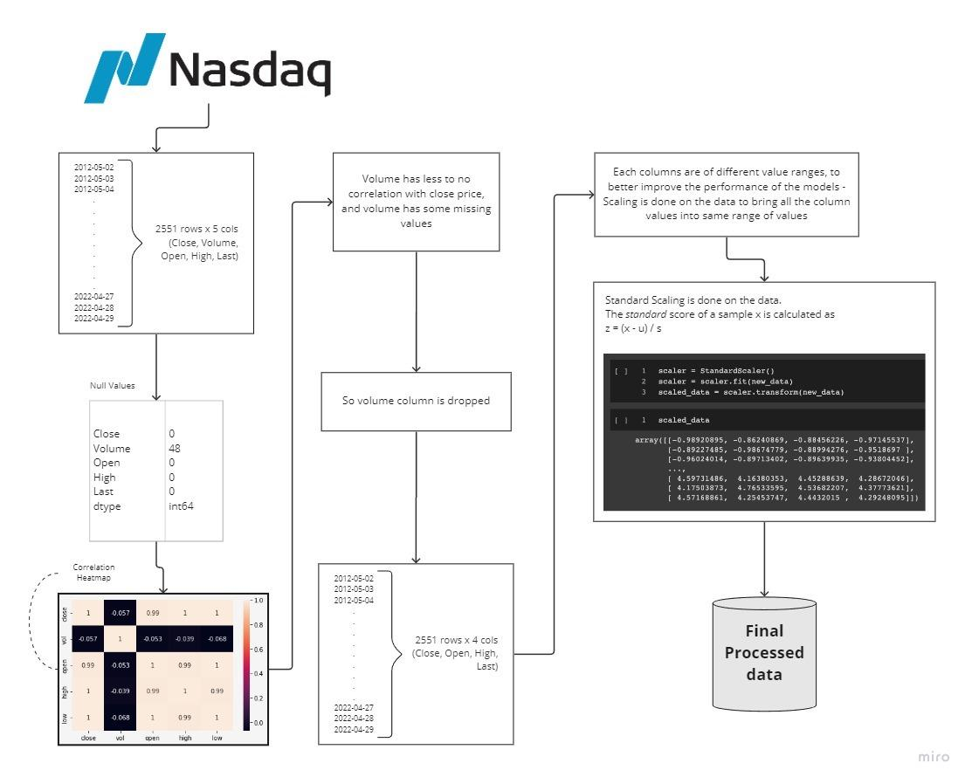

**The preprocessing of data is illustrated in Fig 1**

The nasdaq dataset has 2551 rows and 5 columns initially

where the null entries have been eliminated and correlation heatmap has been used to represent variation of related data in a palette of color.

The volume has been dropped due to minimal or null correlation with the closing price. The ranges of the values varies in each column and hence for better optimisation and performance standard scaling is done to neutralize the range of values which results the final processed data

❖The presented paper avails data preprocessing and data scaling using Min Max scaler for better optimisation. In this model, the total number of lags or differencing amount applicable to the data and the stationarity is verified. The resultant outputs are interpreted to that of multiple regression models.

❖ Long - Short Term Memory is a noteworthy model RNN which is eligible for swotting long term data dependencies. This achievement of the model is due to the interaction of the combined layers. Persistent memory is one of the use cases of this model. It is a pro handler of vanishing gradient problem handled by RNN

❖ In bidirectional LSTM, in spite of training a single model, a second model has been introduced. The first model learns the provided input sequence whereas the second model learns the reverse of that destined sequence. It also increases the information amount improving the algorithm. However the bidirectional neurons do not interact with each other.

❖ Neural Prophet increases the model accuracy, where components of some model can be marshaled into neural networks. This model uses hyperparameter selection which adds more compatibility to the developers. Prophet always marks standards of industry. NeuralProphet reforms Prophet from the bottom up, stressing the challenges with replacement of Stan with PyTorch, which is both easy to use and pliable. This helps in the advancement of the developers to add upon new features with their extended framework and to adopt into new research technologies.

# Background

Numerous research scholars have used various models for forecasting the prices of natural gasses. [1] The gray forecasting model is the core ideology behind the prediction where the differential equation played the sequential role. [2] The models of linear regressors, decision trees, and support vectors have been illustrated for the forecast. [3] Classical Forecasting of integrated approach by least square time series approach with all classical and neural network models. [5] Casting is done over the horizon from 1 to 48 hours which is based on a stepwise regression method. [6] The hybrid version of SVM with Genetic algorithms is deployed to calculate the optimal values of the parameters. [7] Rather than using traditional algorithms, the Fourier transform-based random walk forecasting model is the resulting factor for the effectiveness of the estimations.

[8]Artificial neural networks are trained with backpropagation and artificial bee colony algorithms. After the training module, it is seen that the ABC model gave clear results as it involved two hidden layers. [9] Online - calibrated time series model with day-ahead natural gas demand plays with the casting. [10] It has two phases including the classification and the training of multiple autoregressive Guassian process models. [12] Linear Programming reformulation has been employed to analyze the problem theoretically which is further followed by a stochastic scenario tree. [14] Also uses EGTran, a stochastic model which considers random outages of generating units and transmission lines for forecasting. [16] A prophet-GRU nonlinear combined forecasting model based on an improved BP neural network has been employed for accurate forecasting. [18] A hybrid prediction model which uses an improved whale swarm algorithm and relevance vector machine. In addition to EMD, apEn and C-C methods are being introduced in the model. [20] ARIMA and latin hypercube have been integrated to generate the designated model.

# Proposed model

**Synopsis of the proposed models:**

## AutoRegressive Integrated Moving Average (ARIMA)

## Long-Short Term Memory Model

## Bidirectional LSTM

## Neural Prophet

## AutoRegressive Integrated Moving Average (ARIMA):

## ARIMA model is a popular and widely used statistical model for time series analysis and forecasting. In simpler words it is a kind of model that uses time series data either to better draw conclusions from the dataset or to predict the future trends. A time series data is a set of values collected in regular intervals of time, in intervals of seconds, minutes, hours or daily, weekly or even in yearly periods. For instance, an ARIMA can predict the future price of stocks with the help of the past trends and analysis.

## Autoregressive models, as the name suggests, for a given dataset it assumes that the future will resemble its past data. A statistical model is said to be autoregressive when it is able to predict the future values based on the given past data.

## The name ARIMA stands for AutoRegressive Integrated Moving Average. It is a level up or a better version of the previous simpler model which is quite normal as compared to ARIMA which is just the AutoRegressive Moving Average, where the concept of Integration is included in the ARIMA model.

## *Long-Short Term Memory Model*

LSTM is a recurrent neural network model predominantly used in case of sequence prediction problems that has feedback connections. Also capable of processing entire data sequences rather than single data points such as texts, images,etc.. The parts of LSTM are known as gates. The gates are

★Input Gate

★Output Gate

★Forget Gate

The first and the foremost part chooses whether to remember the information from the precursory timestamp is relevant or to be remembered. In the event of irrelevance, it can be forgotten. The second segment, the cell will be trying to learn new information from the input. Finally, in the last segment, the cell transfers the information updated to the next timestamp right from the current timestamp.

**Sigmoid:**

Sigmoid activation is similar to that of tanh activation. Instead of pushing the values between -1 and +1, it pushes the values between 0 and 1. Helpful in updating the data making it to forget as anything multiplied by 0 produces a 0 always. Anything which is multiplied by 1 is always a 1 making the data to be remembered. Therefore, the network can easily learn to distinguish among which data to remember or forget.

**Activation of tanh:**

The vectors flowing via a neural network undergo many transformations due to various operations of mathematics. Tanh activation is extensively used in regulating the values flowing through the network. The internal operations of tanh are very less but works fine with the given circumstances. It pushes the values between -1 to +1

**Forget Gate:**

The gate which decides whether information should be kept or thrown away. Information from previous hidden state and from current input is passed via sigmoid function. The value ranges between 0 and 1.

0 or nearly closer - to forget

1 or nearly closer - to keep

● Xt - Current timestamp input

● Uf - Weight matrix of input weight

● Ht-1 - Hidden state of previous timestamp

● Wf - Weight matrix of hidden state

Input Gate:

Extensively used in quantifying and qualifying the significance of new information which is carried by the input. The equation of the input gate is given below.

● Xt - Input which remains at the current timestamp t

● Ui - Weight matrix of the remaining input

● Ht-1 - Hidden state at the preceding timestamp

● Wi - Weight matrix

Output Gate:

Output gate ranges between 0 and 1 due to the sigmoid function which decides what the next hidden be of. Previous hidden state and the current input state is passed into a sigmoid function. Nextly, the newly modified cell state is passed to the tanh function. Multiplying the tanh output and the sigmoid output gives a clarity on what information the hidden state should carry.

Current hidden state is calculated using the formula given below

Output of the current timestamp is taken by SoftMax activation on hidden state

## *Bidirectional LSTM*

The ideology behind bidirectional LSTM is straightforward sequencing. Moreover, it is the formation of neural networks in both forward and reverse direction. In the streamlined LSTM, the input can flow only in one direction either forward or backward.

The above diagram describes the flow of information from forward and backward layers. The bidirectional LSTM are activated when the sequence to sequence tasks are required. Two activation values are used in this type of LSTM and also there are two outputs from the cell, a new activation, and a new candidate value. The formula for calculating the candidate value is shown below.

The 3 gates which acts as the mastermind are

Since there are two resultant outputs from the LSTM, outputs are given as

Combined Output:

## *Neural Prophet*

An open source library module exclusively used for time series modeling and was introduced by facebook. Based on pytorch, this is an improvised version of the FB Prophet model. It highlights usual cases including scalability and extensionality.

Can also be used in anomaly detection.

The introduction of neural prophet in addition to prophet envisioned frontline engineers and industrial leaders to improvise a wide range of industrial applications. Future values must depend on past observations.

# Experimental Results

In this section, a line graph is plotted initially to analyze the time series. Here, the closing price has been targeted and with which the model is trianed. This ARIMA is a Univariate model.

As, the interreference that the above graph shows a trend, which implies the data follows a seasonality. Where the data is non-stationary. To be more precise, the seasonality in a time series can be identified using a autocorrelation plot and partial autocorrelation plot. ARIMA models work only when the given time series data is Stationary.

## *ARIMA:*

In this section, a line graph is plotted first to analyze the time series.Here, the closing price is taken as target and with the model is trained. This ARIMA is a Univariate model.

**Line graph of the ARIMA model is depicted in Fig 2**

From the above inference, that the above graph shows a trend, which implies the data follows a seasonality. Where the data is non-stationary. To be more precise, the seasonality in a time series can be identified using a autocorrelation plot and partial autocorrelation plot. ARIMA models work only when the given time series data is Stationary.

From the inclusion. it is seen that both the ACF plot and PACF plot, has got some periodical pattern, which is very likely to follow some seasonal component.

Also there is another method, for concluding that the data is stationary or not. There is a method to test for stationarity of a given time series using an adfuller test.

Augmented Dickey-Fuller is a test done to check whether a time series data is stationary or not. It is a Hypothesis test stating a Null Hypothesis that a root exists for a AutoRegressive time series data. If the result of adfuller test is less than or equal to 0.05, the Null hypothesis can be rejected and conclude that the time series data is Stationary.

The test is done for the time series for the chosen target and the result happens to be concluding that the data is Non-Stationary. So, it is confirmed that the data follows some seasonality and it is obvious to do the differencing on the time series.

Picking the right differencing order or the d value totally depends on the nature of seasonality the time series follows. After getting the d value, proceeding further by finding the other 2 parameters. There are two ways to find the differencing value, either by observing the nature of seasonality in the time series using plots, or by using the pmd arima package to get the number of differencing. For the current time series, the resultant number of differencing to be done as 1. So the d value can be turned to be 1.

The next step is to plot ACF and PACF plots in order to find the other two parameters p and q.

## *ACF and PACF plots:*

* ACF: ACF stands for the Autocorrelation Coefficient Function, which defines how the time series data are correlated to its previous values. It is used to determine the q term in the ARIMA order.

* PACF: PACF stands for the Partial Autocorrelation Coefficient Function, which determines the p term of ARIMA order.

Autocorrelation Plot:

This is the ACF and PACF plots after the differencing is performed on the time series. Now, it is inferred that both the ACF plot and PACF plot decay very fast, such that the data is made stationary. The plot can be accepted if only less than 5% of dots lie outside the blue shaded region.

When looking at both the ACF and PACF plots, ignore the lag 0 which has the long spike. The cut off at ACF plot will give the order q for moving average part. And the cut off at PACF plot will give the order p for the autoregressive part.

Since the both ACF and PACF plots have been cut off after lag 4, the value has been set to 4 for both p and q metrics. Now the ARIMA order(p,d,q) as (4, 1, 4).

The predictions have been made for a time series for the past 510 (past 20%) observations..

**Fig 3 shows the resultant predictions of the model**

And the results are quite good. The mean absolute percentage error falls to be less than 0.03143, which is quite good for the very shot period of time it takes to train the model.

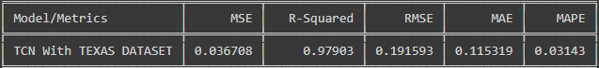

**Metrics of the model has been figured in gig 4**

## *LSTM:*

This section analyzes Multivariate time series forecasting done in a LSTM model. For this multivariate forecasting, taking 4 features into consideration for training the model. The closing, open, highest and the day’s last price value of natural gas. Though all the data of each feature have values in different ranges, it is important to scale them into the same range.

Before actually defining the LSTM architecture. The data is not prepared for the LSTM model to use. After all the data cleaning, preprocessing and scaling is done. First step is to reframe the time series data for the LSTM model. The structure is just the test length which is the number of previous observations that will be used to predict the next observation. And the future_length of observations to be predicted by the model.

In this case, 14 numbers of past observations are used and try to predict one future observation. With these values the data is transformed for ready to use by the model.

The model proposed here is constructed with an input layer with input shape having 14 observations of all 4 features ( , 14, 4), and two hidden layers of LSTM model both using relu as activation function. One Layer has 64 units of neurons and the other layer has 32 units of neurons. Applied with a dropout layer with a dropout rate of 20% to make sure that the model doesn’t end up with overfitting. The model is compiled using Adam optimizer and MeanAbsoluteError loss.

The model is trained with the already transformed training data and the number of epochs is set to 100 with batch size of 16. The batch size plays an important role in the part where the internal state of LSTM in keras does reset itself after each batch. So, the size of the batch is quite important to test with.

**Fig 5 shows the actual prediction of the depicted model** 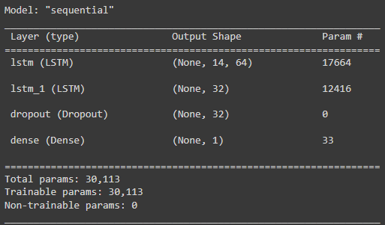

The predictions are made same as done for the ARIMA model, for the past 510 (past 20%) observations. After the predictions are made, it is very important to remember that the result of the model, will be a scaled value. So reverse scaling is done to get back the normal values

The results are quite good as well. The mean absolute percentage error is less than 0.0362.

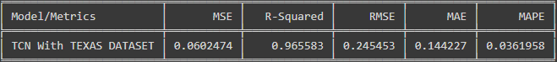

**Fig 6 shows the evaluation metrics of the prescribed model**

## *Bidirectional LSTM:*

An extension of ancient LSTM which helps in improving the model performance of sequence classification problems. Two directional layers are used in this model. In the first layer, the data is given in the forward layer and in the second layer, the data is given in the reverse direction. As mentioned in the traditional LSTM, before initializing the construction of BLSTM, the data must be processed and scaled using Minmax scaler.

To forecast using BLSTM, four features of the dataset are taken into consideration which are the closing, open, highest and the day’s last price value of natural gas. Though all the data of each feature have values in different ranges, it is important to scale them into the same range. A set of past observations are used for future predictions. In this scenario, the 5 past observations has been brought into the show to predict 1 future observation

The model is constructed by having 5 past observations of all 4 past features with three hidden layers where all layers have 50 neurons each. Dropout layer is added to make sure that the model doesn’t get overfitted. The model is compiled using Adam optimizer and MeanSquaredError loss. The Bayesian prediction is used due to its ability to incorporate prior info to the analysis, and estimates missing values together with the parameter values.The epochs value is set to 50 with the batch size of 5. The size of epoch is to be taken into account as the LSTM in keras resets after each iteration.The summary of the model is given below.

**Fig 7 shows the evaluation metrics of the experimented model**

The prediction of the constructed model is shown below

**Fig 8 shows the actual prediction of the deployed model**

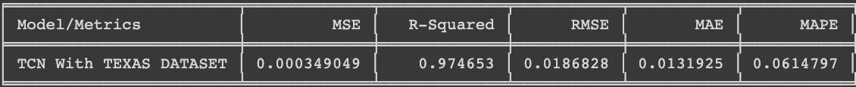

**Fig 9 shows the accuracy of the resultant model**

The Mean absolute percentage error happens to be less than 0.0614.

## *Neural Prophet Model*

An extension of Prophet model which is inspired by Facebook Prophet and AR-net libraries. Uses gradient descent optimisation for making the model engine much faster. Also uses AR-net libraries for autocorrelation and minimum custom losses and metrics. In addition to above use cases, neural prophet supports covariates which are lagged. The required modules and libraries are installed in the premature state. The data frame is indexed by taking the date and the closing price as the attributes. Now, the indexed dataframe is converted to the proper date-time format. The figure of the dataframe is plotted initially.

Before the actual prediction, the maximum part of the dataset is used for training and the minimum part of the dataset is used for testing. Now, the predictions are done annually using the constructed Prophet model. Among the different attributes, ‘ds’, ’yhat’, ’yhat_lower’, ’y_hat _ upper’ is only taken into consideration. The forecast of Prophet model is shown below

**Fig 10 shows the daily, monthly and yearly prediction**

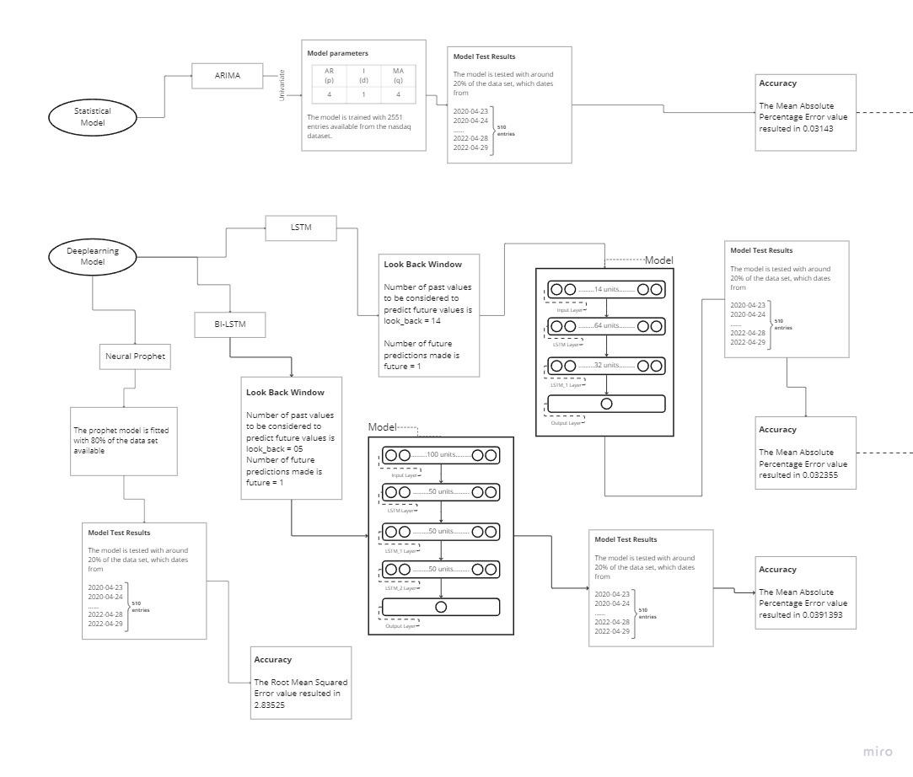

**Fig 11 gives the experimental results of the proposed models**

# *CONCLUSION*

The demand for natural gasses has been ignited in recent decades. The promotion of sustainable living is one of the hitchhiking factors for the forecasting of natural gasses. The proposed models have been lightened up. Among the statistical and deep learning models, once the clear analytics has been performed it is inferred that ARIMA from the statistical model has an accuracy of 0.03143 and LSTM from the deep learning model has an accuracy of 0.32355 when in comparison with the rest of the models. As a hybrid model, both the models together gave the best efficiency and accuracy of 0.308851.

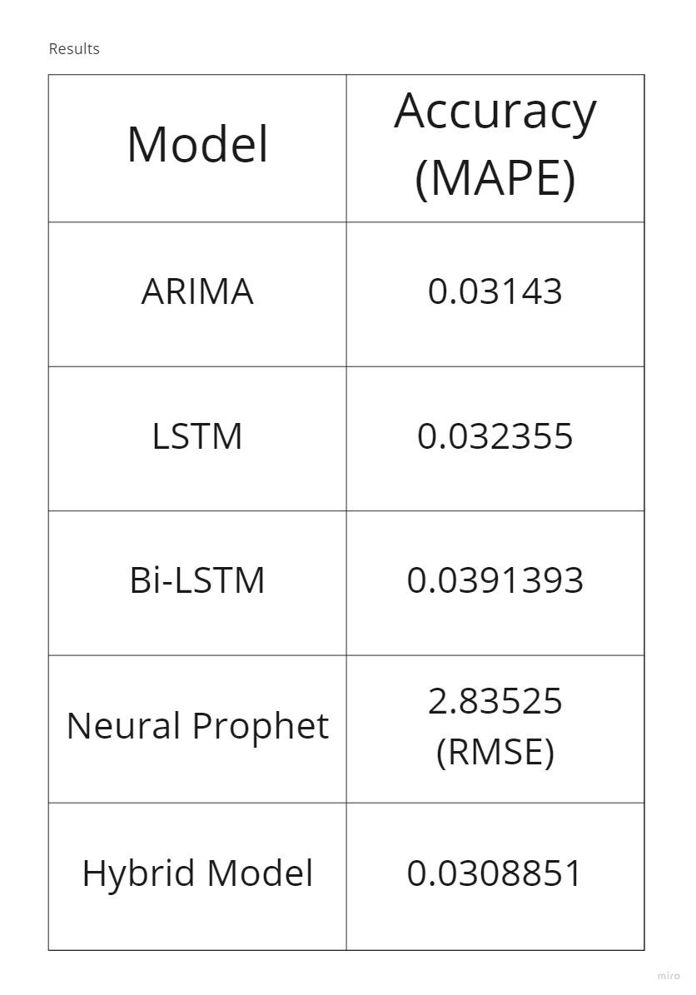

**Fig 12 depicts the overall resultant results**

As a result, the ONG investors and the individual governments can plan and invest in natural gasses accordingly in the upcoming years. In addition to that, our solution will be one of the problem solvers in many aspects

REFERENCES

1. H. Ma and Y. Wu, "Grey Predictive on Natural Gas Consumption and Production in China," 2009 Second Pacific-Asia Conference on Web Mining and Web-based Application, 2009, pp. 91-94, doi: 10.1109/WMWA.2009.26.
2. Z. Sičanica and Z. Oklopčić, "Countywide natural gas consumption forecast, a machine learning approach," 2018 41st International Convention on Information and Communication Technology, Electronics and Microelectronics (MIPRO), 2018, pp. 1070-1073, doi: 10.23919/MIPRO.2018.8400195.
3. P. K. Pradhan, S. Dhal and N. K. Kamila, "Artificial Neural Network Conventional Fusion Forecasting Model for Natural Gas Consumption," 2018 International Conference on Advances in Computing, Communications and Informatics (ICACCI), 2018, pp. 2200-2205, doi: 10.1109/ICACCI.2018.8554500.
4. R. H. Brown, S. R. Vitullo, G. F. Corliss, M. Adya, P. E. Kaefer and R. J. Povinelli, "Detrending daily natural gas consumption series to improve short-term forecasts," 2015 IEEE Power & Energy Society General Meeting, 2015, pp. 1-5, doi: 10.1109/PESGM.2015.7286138.
5. P. Potočnik and E. Govekar, "Applied short-term forecasting for the Slovenian natural gas market," 2016 13th International Conference on the European Energy Market (EEM), 2016, pp. 1-5, doi: 10.1109/EEM.2016.7521227.
6. Q. Liu, P. Lian and H. Liu, "Natural Gas Load Forecasting using Fuzzy Sigmoid Kernel Support Vector Machines with Genetic Algorithms," 2019 Chinese Automation Congress (CAC), 2019, pp. 640-645, doi: 10.1109/CAC48633.2019.8997284.
7. G. Poyrazoglu, "Impact of Gas Price on Electricity Price Forecasting via Supervised Learning and Random Walk," 2019 16th International Conference on the European Energy Market (EEM), 2019, pp. 1-5, doi: 10.1109/EEM.2019.8916448.
8. M. Akpinar, M. F. Adak and N. Yumusak, "Forecasting natural gas consumption with hybrid neural networks — Artificial bee colony," 2016 2nd International Conference on Intelligent Energy and Power Systems (IEPS), 2016, pp. 1-6, doi: 10.1109/IEPS.2016.7521852.
9. H. Khani and H. E. Z. Farag, "An Online-Calibrated Time Series Based Model for Day-Ahead Natural Gas Demand Forecasting," in IEEE Transactions on Industrial Informatics, vol. 15, no. 4, pp. 2112-2123, April 2019, doi: 10.1109/TII.2018.2861390.
10. O. Laib, M. T. Khadir and L. Mihaylova, "A Gaussian Process Regression for Natural Gas Consumption Prediction Based on Time Series Data," 2018 21st International Conference on Information Fusion (FUSION), 2018, pp. 55-61, doi: 10.23919/ICIF.2018.8455447.
11. A. Shiri, M. Afshar, A. Rahimi-Kian and B. Maham, "Electricity price forecasting using Support Vector Machines by considering oil and natural gas price impacts," 2015 IEEE International Conference on Smart Energy Grid Engineering (SEGE), 2015, pp. 1-5, doi: 10.1109/SEGE.2015.7324591.
12. V. Kalashnikov, N. Kalashnykova and F. J. Castillo-Pérez, "Bilevel Natural Gas Cash-Out Problems: Deterministic and Stochastic Approaches," 2016 Second International Symposium on Stochastic Models in Reliability Engineering, Life Science and Operations Management (SMRLO), 2016, pp. 544-555, doi: 10.1109/SMRLO.2016.96.
13. Z. Zhang, C. Wang, S. Chen, Y. Zhao, X. Dong and X. Han, "Multitime Scale Co-Optimized Dispatch for Integrated Electricity and Natural Gas System Considering Bidirectional Interactions and Renewable Uncertainties," in IEEE Transactions on Industry Applications, vol. 58, no. 4, pp. 5317-5327, July-Aug. 2022, doi: 10.1109/TIA.2022.3169737.
14. X. Zhang, M. Shahidehpour, A. Alabdulwahab and A. Abusorrah, "Hourly Electricity Demand Response in the Stochastic Day-Ahead Scheduling of Coordinated Electricity and Natural Gas Networks," in IEEE Transactions on Power Systems, vol. 31, no. 1, pp. 592-601, Jan. 2016, doi: 10.1109/TPWRS.2015.2390632.
15. R. Hribar, G. Papa and J. Šilc, "Prediction of natural gas consumption using empirical models," 2017 International Conference on Smart Systems and Technologies (SST), 2017, pp. 31-36, doi: 10.1109/SST.2017.8188665.
16. Y. Zhou, S. Chen and D. Xiao, "Study on Natural Gas Price Forecasting Based on Prophet-GRU Nonlinear Combination," 2022 7th International Conference on Computational Intelligence and Applications (ICCIA), 2022, pp. 118-122, doi: 10.1109/ICCIA55271.2022.9828442.
17. J. Enderlin, B. Dal Ferro, B. Loire, Z. Bacsi, S. Bredin and A. Vallette, "Advanced simulation solutions to overcome limitations to forecasting scenarios for natural gas trading," 2017 14th International Conference on the European Energy Market (EEM), 2017, pp. 1-7, doi: 10.1109/EEM.2017.7981907.
18. W. Qiao, K. Huang, M. Azimi and S. Han, "A Novel Hybrid Prediction Model for Hourly Gas Consumption in Supply Side Based on Improved Whale Optimization Algorithm and Relevance Vector Machine," in IEEE Access, vol. 7, pp. 88218-88230, 2019, doi: 10.1109/ACCESS.2019.2918156.
19. O. Laib, M. T. Khadir and L. Chouireb, "Forecasting yearly natural gas consumption using Artificial Neural Network for the Algerian market," 2016 4th International Conference on Control Engineering & Information Technology (CEIT), 2016, pp. 1-5, doi: 10.1109/CEIT.2016.7929041.
20. S. Yu, S. Yan, X. Liu, B. Liu, C. Xiong and J. Liu, "Day-ahead optimal dispatch of integrated energy system considering wind power forecasting and integrated demand response," 2020 IEEE 1st China International Youth Conference on Electrical Engineering (CIYCEE), 2020, pp. 1-7, doi: 10.1109/CIYCEE49808.2020.9332688.
21. A. Petrella and S. Sapio, "A time series analysis of day-ahead prices on the Italian power exchange," 2009 6th International Conference on the European Energy Market, 2009, pp. 1-6, doi: 10.1109/EEM.2009.5207141.